FORNAX™ ePlanCheck Rule
Rule Information
Rule ID | SSW 2.1.7 (a)
Rule Name | Manhole Standard Material
Chapter | 2 Sewerage Works
Section | 2.1 Design Requirements for Sewers
Handbook | Code of Practice on Sewerage and Sanitary Works  Addendum No. 2 - Nov 2004

Rule Description
2.1.7 Sewer Manhole
- All sewer manholes shall be constructed using pre-cast circular units or chamber rings in compliance with the Department’s Standard Details of Manholes. These Details are found in appropriate Standard Drawings produced by the Department.

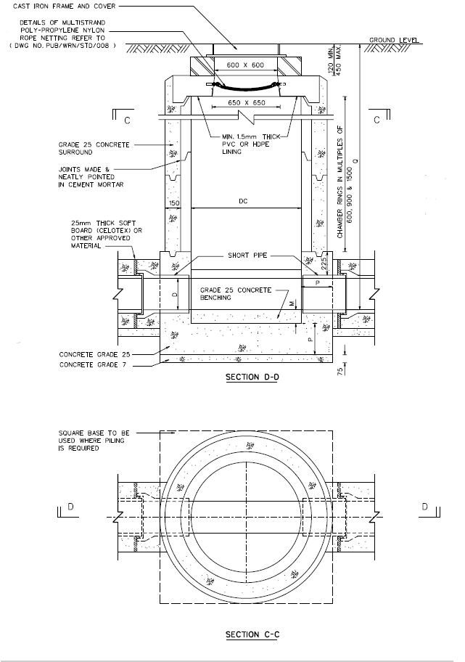
DEPARTMENT’S STANDARD DETAILS OF MANHOLES

Rule Interpretation
- This rule checks that sewer manholes are constructed using pre-cast concrete.

Rule Scenario
FIGURE SCENARIO
Scenario 01 – Compliant
Requirement | Material shall be Pre-cast Concrete.
Description | Material used for the manhole is Pre-cast concrete.
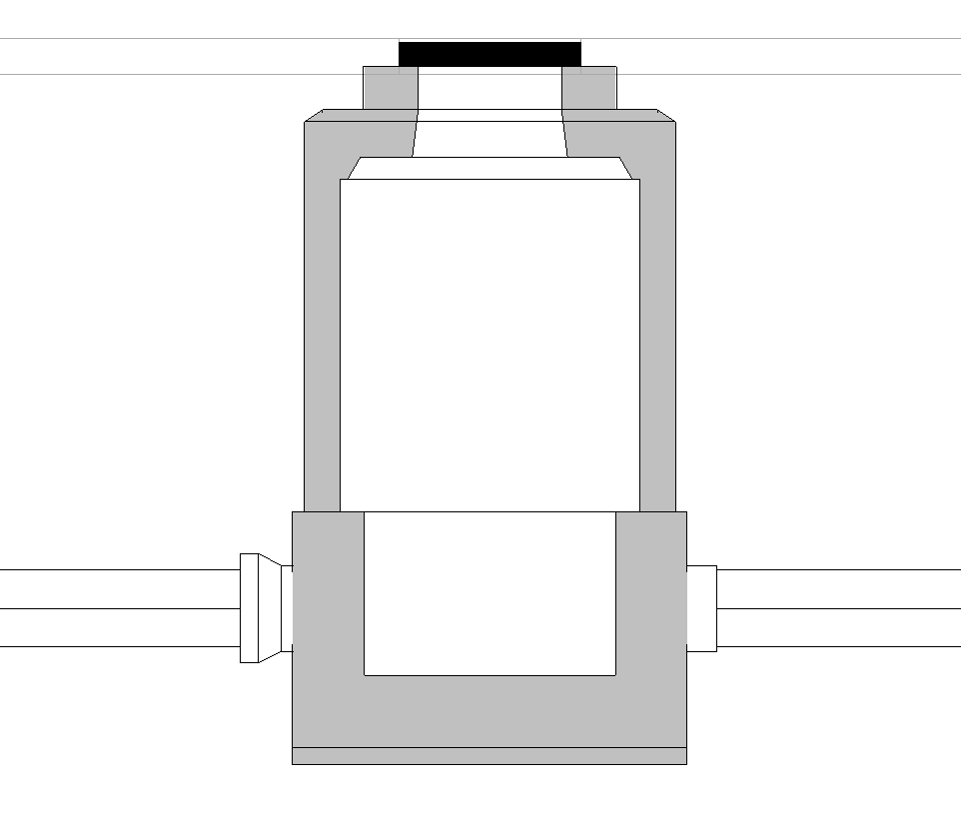
PRE-CAST CONCRETE
MANHOLE SECTION
FIGURE SCENARIO

Scenario 01 - Non-Compliant
Requirement | Manhole Material: Pre-cast Concrete
Description | Material used for the manhole is Cast In-situ concrete.
MANHOLE SECTION
FIGURE SCENARIO

CAST IN-SITU CONCRETE CONCRETE

Request For Information

- When is the time that we need to use the rectangular manhole? The Rule Description only mention the circular or the ring type manhole but in the Standard Drawings there is also rectangular type.
- Reference: WRN_STD_001A

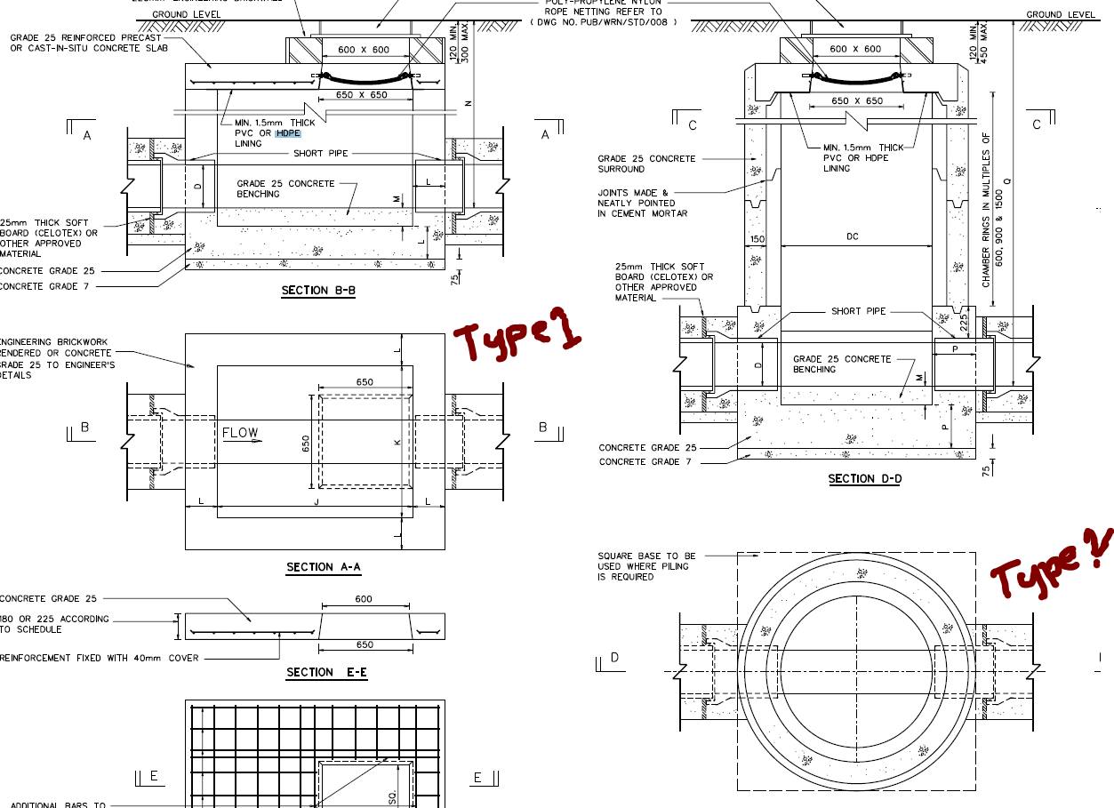

Model PreCheck

Required Elements | Required Attributes
DistributionChamberElement | IfcName contains “Sewer Manhole”

Rule Parameters

System Type
Cold Water
Hot Water
 | Sanitary
 | Sewerage | 
Vent

Element Type 1
State | Type | Property | Operator | Value
Include | DistributionChamberElement | Name | Contains | Sewer Manhole
Exclude |  | Any | Match | <User define>
 |  |  | N.A. | N.A.

Element Type 1 Condition
* Shall have a material containing Pre-cast concrete only.

Result Messages
- 2.1.7 (a) Manhole Standard Material
  - Non-compliant (TotalResultNumeric)
    - BuildingStorey (TotalResultPerFloorNumeric)
    - ElementType1Name is not Circular
    - ElementType1Name is not Pre-cast concrete
    - ElementType1Name is not Circular and Pre-cast concrete

  - Compliant (TotalResultNumeric)
    - BuildingStorey (TotalResultPerFloorNumeric)
    - ElementType1Name is Circular and Pre-cast concrete material

  - Attention (TotalResultNumeric)
    - BuildingStorey (TotalResultPerFloorNumeric)
    - No Element Type 1 is found.

Sample Result Messages
- 2.1.7 (a) Manhole Standard Material
  - Non-Compliant (1)
    - Level 1 (1)
    - Manhole: PVC material; Material used for Sewer Manhole is not Pre-cast concrete.
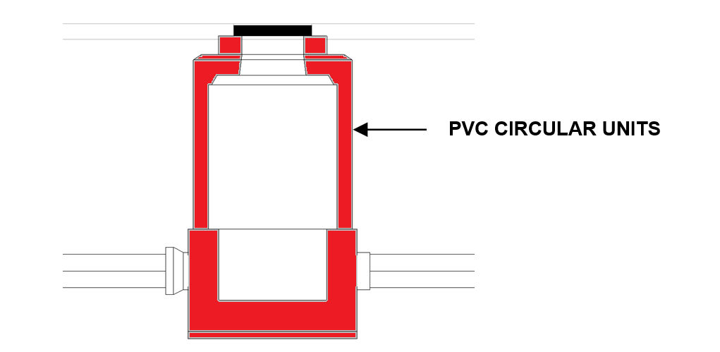
  - Compliant (1)
    - Level 1 (1)
    - Manhole: Pre-cast concrete material; Pre-cast concrete material is detected
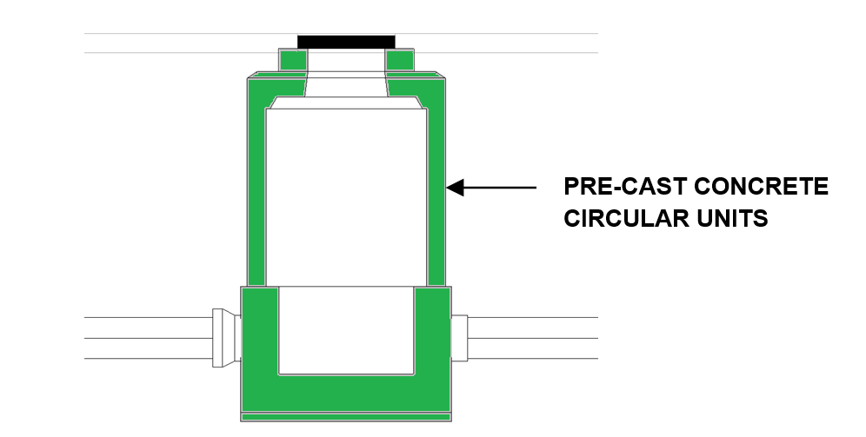

  - Attention (1)
    - Level 1 (1)
    - No manhole found.

Sample Result Model Views
- 2.1.7 (a) Manhole Standard Material
  - Non-Compliant
    - Side View.
    - Manhole is displayed.
    - All other elements are translucent except manhole.

  - Compliant
    - Side View.
    - Highlight checked Manhole.
    - All other elements are translucent except manhole.

Testing Scenario Notes
- Scenario 01 - Compliant
- Level 01
- Material used for the manhole is Pre-cast concrete.
`
- Scenario 01 – Non-Compliant
- Level 01
- Material used for the manhole is PVC.

Model:
SSW 2.1.7 (a) Compliant.ifc
SSW 2.1.7 (a) Non-Compliant.ifc

Modelling Guideline
- Specify IfcName and IfcExportAs containing “Sewer Manhole” for relevant DistributionChamberElement.

Specification Log
RA | Kawther B. Tabernero
Last edit date | 6 November 2018
ePC version
Updates | - V1

